ANMA ANNUAL MEETING & GENERAL ASSEMBLY
19. - 20. May 2015
Stockholm University of the Arts

Tuesday, 19th May
THEMATIC DAY: Music Education and Social Contracts with Societies. What Role Do ANMA and its Members Play?
Welcome by Paula Crabtree, Rector of Stockholm University of the Arts
Welcome by Thomas Winther, General Secretary of ANMA

KEYNOTE PRESENTATIONS

1. The Nordic Culture Fund – and its Role as a Facilitator of Development within the Cultural Field in the Region by Benny Marcel (Nordic Culture Fund)

Nordic Culture Fund
- Providing grants since 1966
- Primary aim to promote and invest in Nordic cultural cooperation
- Supports cultural projects that rethink and recreate the concept of what is Nordic and enhance cultural life in the region
- Funding can be combined with other Nordic funding schemes (e.g. Nordplus)
Organization
- Board
13 members, appointed for 2 years by Nordic Council and Nordic Council of Ministers
- Experts
22 members, appointed for 3 years, provide Quality Assurance
- Secretariat
Day-to-day running of the Fund, contacts with the applicants
Director, 4 advisors and student workers
Projects
- At least 3 Nordic countries
- Art and culture
- Open to professional and amateur applicants
Focus areas
- Children and young people
- Diversity and inclusion
- Nordic neighbouring languages
- Sparsely populated areas
Application must show
- Nordic dimension
- Quality (artistic and cultural objectives)
- Support – how the project will be supported in other Nordic countries
- Impact
OPSTART
- New funding scheme for start-ups
- At least 2 Nordic countries
- No deadlines
- No own contribution required
- Answer in 2 weeks

- ANMA could link institutions together who want to apply
- Find the similarities between NCF and ANMA
- What can be done to raise visibility?

2. The Danish performance contract system by Claus Skjold Larsen (Danish National Academy of Music)

Definition
- Agreement on institutional core development activities and financial and activity figures
- Extended mutual letter of intent
- Focus on result management
Process
- Strategic and dialectic dialogue between ministry and the institution, based on trust with the institutional leadership
- Definition of mission, vision and targets
- Agreement on criteria for fulfilment of mission
- Result targets defined for each mission
- Operational targets agreed for each result target
- Operational targets defined as indicators and key figures
Control and follow-up
- Combining finance and activity
- Reports, meetings, interviews
- Quality measurements defined by the institutions
Impact
- Helps towards transparency
- Clearer communication
- Facilitates a more clear position towards the surroundings
- Facilitates internal debate on what we are doing and how we are doing it

3. Musique – Music Quality Enhancement by Martin Prchal and Linda Messas

Definition
- Independent European-level subject-specific external evaluation body established in 2014, aiming to
  - assist higher music education institutions in quality enhancement
  - improve the quality of higher music education as a whole
- Successor of AEC institutional and programme review responsibility
Structure
- 3 partner organisations: AEC, EMU, PEARLE
- 3 main bodies: Board (5 members), peer-reviewers, support team
Services
- Quality enhancement reviews (institutional, programme, joint programme), each with a specifically defined set of standards
- Accreditation procedures
- Joint procedures with national accreditation bodies
- QA desk
3-step procedure
- Self- evaluation report
- Site-visit of the review team
- Report of the review team
Internal and external QA mechanisms
- Feedback questionnaires, reports
- External evaluator and reviews
Beneficiaries
- Higher music education sector – strengthened credibility
- Institutions – standards based on specifities of the music sector
- Staff and students – improved educational offer and recognition
- National Accreditation Agencies
Future development
- Formal registration on EQAR (European Quality Assurance Register)
- Musique as the provider for review and accreditation in music
- Standards for pre-college training and music teacher training
- Potential to act as a review body in multidisciplinary institutions
Musique and ANMA countries
- Presentation of if and how Musique can be incorporated in the national accreditation procedures and systems

IRC/ANMA joint meeting: Strengthening ties on a strategic level between ANMA and Nordplusmusic
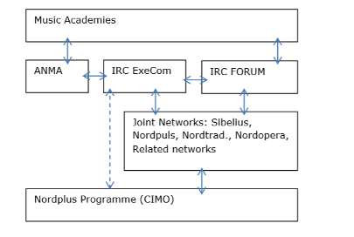
Introduction of international work from different perspectives

Rector: Ann-Charlotte Carlén (Malmö Academy of Music)
- One of 3 academies in Faculty of Fine and Performing Arts
- Performance programme and Music Education programme
- Inter Arts Centre – platform for Artistic Research
- Exchange programmes for student and staff mobility
- European and Nordic networks: European Association for Music in Schools, NNME, Universitas 21
- Erasmus and Nordplus Intensive Programmes
IRC: Michael Strobelt (The Arctic University of Norway)
- Day-to-day work mainly student and teacher mobility
- While exchange numbers have remained similar over the years, work hours have risen considerably due to:
- Increased amount of email communication and negotiations between students and coordinators mainly about the LA and course content
→ Common standards should be developed; course content info should be easier to find for students
- Online application systems often increase the workload and spent time
→ NOAS needs to be developed further to be taken on European level
Educational administration: Peder Hofmann (Royal College of Music in Stockholm)
- HEI missions: education, research, interaction with the society
- Vision implemented through strategic aims
- Four crucial cornerstones
  - Legal contract
  - Transparency in curriculum
  - Transparency for students
  - Funding after project funding terminates
- Four challenges/opportunities
  - Knowledge about national regulations
  - Semester structures
  - Funding programmes and projects
  - Live as we learn
Student: Sylvain Devaux (CoPeCo programme, CNSMD Lyon)
- Joint MA programme CoPeCo as a two-year residency to develop a personal project
- Opening new artistic and personal horizons and identity
- No specific content and goal to reach provided
- Possibility to step back from personal experience and put it in the perspective of a broader context
- How to function as a group: different speeds, needs, approach, but shared desire for exploring. Hard to find a common ground in terms of musical and artistic needs
- Professional contacts and contacts of the institutional level could be strengthened (internships, projects)
- Aim to develop to become a European musician

Positioning your international work on the 4-dimensional scale

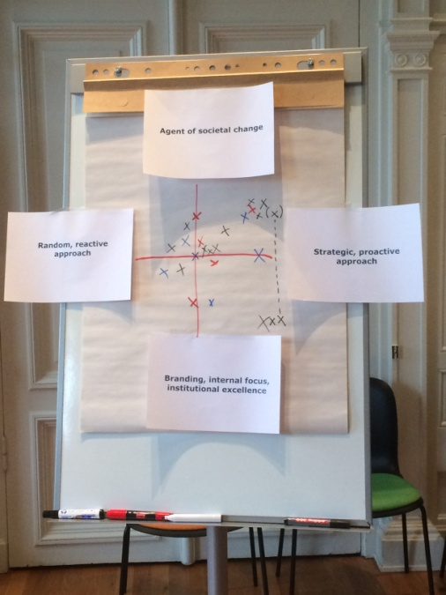

- Each school can be/is in many places at the same time
- Need to share the results and experiences
- Connection between ANMA and IRCs should be strengthened at home

Input to ANMA strategy

Branding the Nordic area
- Nordic academies as regional powerhouses for the regional ecosystem
- National repertoire, artistic research, Nordic music library
- Good education, facilities, environment, English skills
- Frontrunners in pedagogical discourse, provide pedagogical expertise
- Strong areas: Nordic jazz, classical, traditional, contemporary music
- Focus on projects that make sense in the Nordic context
- Analyse what the common challenges are, where the infrastructure is in place to address them
- Joint marketing
Closer connection between ANMA and IRCs
- Connection of ANMA ideas to concrete work/projects in N+
- Joint ANMA/IRC meetings – strengthen strategic connections
- Meetings between annual meetings
- Thematic working groups instead of big joint meetings with members from both ANMA and N+
- WG for revitalising activities after the end of the N+ programme period
Curriculum reforms
- Benchmarking
- Further support the development of entrepreneurship and entrepreneurial mindset
- Partnerships with the business sector
- Windows for internships, individual specialisation
- Thematic exchanges
- Nordic platform/forum for projects that are created and driven by students

Wednesday, 20th May
GENERAL ASSEMBLY

1. Approval of Agenda
- The Agenda was approved
2. Election of the chairman
- Kaarlo Hildén was elected as the chairman
3. Status reports from all countries (5 minutes for each country)
Denmark
- Claus Olesen (RAMA) updated on Denmark
- All education institutions have made performance contracts for the next 4 years
- New tasks given to education/research/art and culture institutions
- Positive developments in terms of recruitment
- Large scale reforms changed how music schools are operated
Estonia
- Peep Lassmann (EAMT) reported from Estonia
- Joint MA programme CoPeCo has been launched
- No changes in higher education policies, major changes coming up next year
- Coordinating and hosting Nordplus events: IP Girl Power in Jazz, Nordopera audition
Finland
- Kaarlo Hildén presented Finland
- Politically turbulent time in educational policies. Severe cuts in public funding
- Continuation of the renewal of the HE system
- Close collaboration between educational institution and independent research institutions
- New contracts for the Universities for Applied Sciences. Funding cut 20%
Iceland
- Tryggvi Baldvinsson reported from Iceland
- New Dean of Music the Iceland Academy of the Arts
- Composition MA programme revived
- Preparation of vocal/instrumental pedagogy MA programme for 2016
Latvia
- Artis Simanis reported from Latvia
- Member of Nordplus networks: Sibelius, Nordpuls, Nordtrad, Nordopera
- Coordination and participation in Nordplus activities: Viatore project, Percussion Plus, Nordopera Biennale, Girl Power in Jazz, Crossing Keyboards etc
- Joint concert of the 3 Baltic rectors
Lithuania
- Zbignevas Ibelgauptas presented Lithuania
- Participation of Sibelius, Nordpuls, Nordtrad networks, coordination of the Nordopera network
- Hosting of Nordopera Biennale
- New curricula: Digital production, Music therapy
- LMTA HARPS, platform of the Research Centre
- Project of the new LMTA campus, open tender resulted with 28 architectural solutions
Norway
- Frode Thorsen reported from Norway
- Close contact between the member institutions in the Council of Norwegian Music Academies
- Updates from the SAK project (Samarbeid (cooperation), arbeidsdeling (division of labor), konsentrasjon (concentration) – a joint project for all Norwegian academies
- Focus on developing long-term cooperation
- First phase – national survey. Most graduates are satisfied with work and find education relevant. Second phase – info about applicants collected. Third phase – a group of experts analysed the material and visited all institutions. A final report was presented December 2014
- Discussion about structural changes: number of institutions reduced in Norway, some big mergers
- Peter Tornquist informed ANMA about Centre of Excellence in Music Performance Education at the Norwegian Academy of Music.
Sweden
- No representative
- New government, don’t yet know what the new budget will be like
4. Acceptance of new ANMA members
- Karelia University of Applied Sciences was accepted as a member of ANMA
5. Accounts of 2014
- Keld Hosbond presented the accounts for 2014 and the audit report from auditor Knut Myhre
- Accounts were approved
6. Budget and membership fees for 2015+2016
- Keld Hosbond presented the budget for 2015 and 2016
- Suggested annual membership fee 2016: 600 EUR for institutions with more than 400 students, 300 EUR for institutions with less than 400 students
7. Information from EXCOM
- Minutes of the last EXCOM were introduced
- The minutes can be found at http://www.nordplusmusic.net/index.php?id=334
8. Summary from thematic day and discussion on a process for a new strategy/plan of action
- A lot of good ideas were presented – will be taken up by the new EXCOM and General Secretary
- Many common challenges for institutions related to the societal change
- Smaller WG to prepare suggestions
- A concrete plan of action for the next years
- Challenges in precollege education → joint application for exchange of ideas and development of educational systems
- Which directions do the institutions want to go to (2nd step for positioning on the 4-dimensional scale)
9. ANMA/AEC relations
- Council meeting in Berlin one month ago
- AEC membership becoming more and more diversified. Reaching in several directions, difficult to find a common core for strategy
- Regional cooperation will grow in importance
- EXCOM and General Assembly will need to look into the FULLSCORE project to define if there are specific wishes as a region
10. ANMA relations to other regional organisations
- Peep Lassmann reported from the SEADOM Congress 2015
- Very dynamic region, all South-East Asian countries belong to the organisation
- Active discussions, similar discussion topics to our conferences
- Genuine interest in cooperation with Europe, especially regional organisations like ANMA
- Conference 2016 will be held in Laos
11. Report from Orkester Norden
- Michael Pilgaard, General Manager from 2013, presented Orkester Norden
- Orchestra increased to 80 in 2014
- 3 mission anchors: strengthening and growing of Nordic culture; development of skills of being a musician in a professional symphony orchestra; new concert formats, new audiences
- Upcoming projects: 25th anniversary in 2017
- ANMA has a seat in the Board
12. Nordplus activities/NOAS
- Launched as a 3-year pilot, yearly evaluations
- Challenge – needs updating and maintenance
- Formal contract between the IT department and the Grieg Academy
- Negotiations between Bergen and ANMA new representation
- A very good system is needed before expanding on the AEC level
- Step-by-step approach – take in more institutions gradually, 30 institutions at a time
13. Next Annual Meeting (2016)
- 2016 – Estonian Academy of Music and Theatre, Tallinn
- 2017 – The Arctic University of Norway, Tromsø
- Suggestion for a stronger connection to the AEC agenda
- Suggestion to combine the Annual Meeting with other events and activities
14. General Secretary situation
- Claus Olesen was appointed as the General Secretary for 2015/2016
15. EXCOM situation
- The 2-year period of the current EXCOM is running out, new members need to be appointed
- Mist Thorkelsdottir will represent Sweden
- Eero Linjama will represent Finland
- Frode Thorsen will represent Norway
16. Information items
- Kaarlo Hildén introduced the International Summer Academy of the Sibelius Academy
- Free of charge for Nordic students due to external funding for master classes
17. Any other business
- Two new auditors will need to be appointed
- Rima Rimsaite from Vilnius and Christofer Fredriksson from Stockholm were suggested

